# MODULE -4.4

# 1.QUESTION

# PROGRAM CODE:

public class StringInstantiation {

public static void main(String[] args) {

// First way: Using a string literal

String myString1 = "abc";

// Second way: Using the String constructor with a string literal

String myString2 = new String("abc");

// Third way: Using a character array

char[] charArray = {'a', 'b', 'c'};

String myString3 = new String(charArray);

// Print the strings to verify

System.out.println("myString1: " + myString1);

System.out.println("myString2: " + myString2);

System.out.println("myString3: " + myString3);

}

}

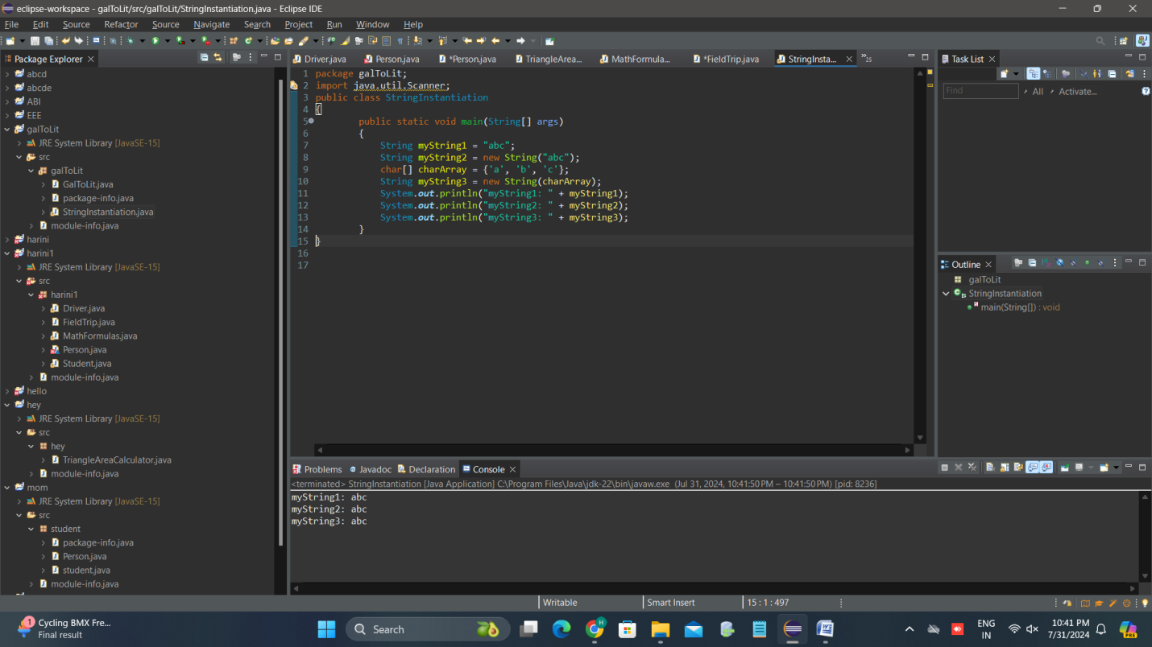

## 2 QUESTION

**PROGRAM CODE :**

public class StringComparison {

public static void main(String[] args) {

String s1 = "ABC";

String s2 = new String("DEF");

String s3 = "AB" + "C";

int resultA = s1.compareTo(s2); // a

boolean resultB = s2.equals(s3); // b

boolean resultC = (s3 == s1); // c

int resultD = s2.compareTo(s3); // d

boolean resultE = s3.equals(s1); // e

System.out.println("a. s1.compareTo(s2): " + resultA);

System.out.println("b. s2.equals(s3): " + resultB);

System.out.println("c. s3 == s1: " + resultC);

System.out.println("d. s2.compareTo(s3): " + resultD);

System.out.println("e. s3.equals(s1): " + resultE);

}

}

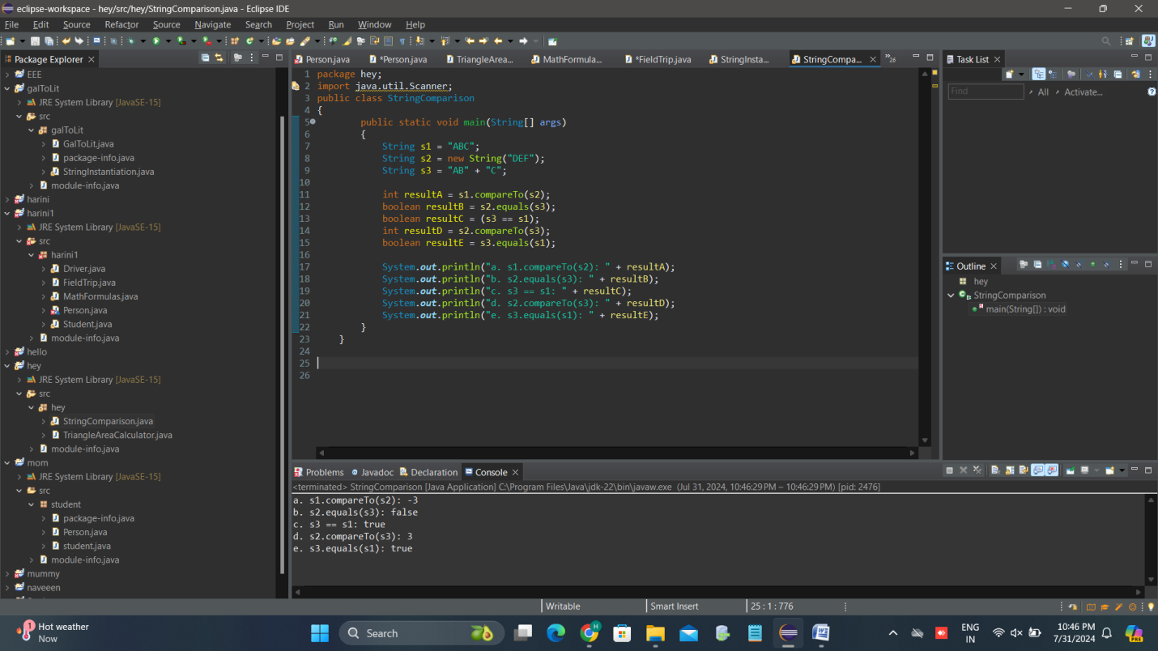

# 3 QUESTION

PROGRAM CODE:

package hey;

import java.util.Scanner;

public class StringConcatenation

{

public static void main(String[] args) {

String string1 = "Hello";

String string2 = "World";

String concatenatedString = string1 + " " + string2;

System.***out***.println("Concatenated String: " + concatenatedString);

}

}

